Year 11 Human Biology - Excretory System Test Mark:_______/48

Name:________________________ Teacher:______________________________

**PART A: MULTIPLE CHOICE (TOTAL 10 MARKS)**

1. The removal of metabolic waste products from the body of a mammal is known as
2. Egestion
3. Excretion
4. Secretion
5. Defecation
6. Which four of the following function as excretory organs?

I Lungs IV Pancreas

II Spleen V Liver

III Kidneys VI Skin

1. I, II, IV, VI
2. I, III, V, VI
3. II, III, IV, VI
4. II, III, IV, V
5. The composition of blood **leaving the kidney** is compared with the blood entering it. Which of the following is most likely?

|  |  |  |  |  |
| --- | --- | --- | --- | --- |
|  | GLUCOSE | CARBON DIOXIDE | UREA | OXYGEN |
| a. | Same | More | More | Less |
| b. | Slightly less | Less | More | More |
| c. | Slightly less | More | Less | Less |
| d. | More | More | Less | More |

1. Which of the following is **not** a function of the kidneys?
   1. Regulating the composition of the body fluid
   2. Regulating the water balance of the body
   3. Regulating the body temperature
   4. Removing the excess salts
2. Alcohol has a direct effect on the pituitary gland in that it causes the suppression of ADH secretion. The final result will cause
   1. More water being reabsorbed by the Bowman’s capsule
   2. More water being reabsorbed by the collecting tubule
   3. Less water being reabsorbed by the Bowman’s capsule
   4. Less water being reabsorbed by the collecting tubule and the distal convoluted tubule
3. The diagram below is of a longitudinal section through the human kidney

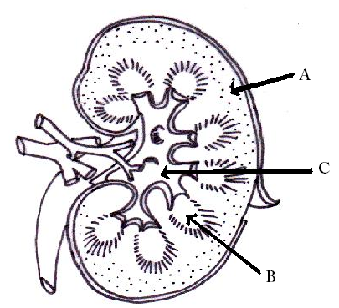

* 1. A is the medulla, B is the cortex, C is the renal pelvis
  2. A is the renal pelvis, B is the cortex, C is the medulla
  3. A is the cortex, B is the medulla, C is the renal pelvis
  4. A is the cortex, B is the renal pelvis, C is the medulla

1. Which of the following cannot be found in the glomerular filtrate inside the Bowman’s capsule:
2. Amino acids 2. Proteins
3. Glucose 4. Glycerol
4. Red blood cells
   1. All except 2
   2. All except 5
   3. 2, 3 and 5 only
   4. 2 and 5 only
5. After a student has run a race on a hot day, what change/changes can be found in the contents of the fluid present in the collecting tube?
6. The concentration of urea will increase
7. A small volume of fluid is produced
8. The amount of glucose will decrease
9. More water will pass out of the collecting tube to increase heat loss
   1. 1 only
   2. 2 only
   3. 1, 2 and 3 only
   4. 3 and 4 only
10. Normally, concentrations of metabolically important substances are:
    1. High in the glomerular filtrate and low in urine
    2. Low in the glomerular filtrate but high in urine
    3. High in both the glomerular filtrate and urine
    4. Low in both the glomerular filtrate and urine
11. The path of the filtrate through the kidney is:
    1. Cortex, medulla, renal pelvis, ureter, bladder, urethra
    2. Cortex, medulla, renal pelvis, urethra, bladder, ureter
    3. Medulla, cortex, renal pelvis, ureter, bladder, urethra
    4. Cortex, renal pelvis, medulla, ureter, bladder, urethra

**PART B: VOCABULARY (TOTAL 8 MARKS)**

1. The ___________________ are the functional units of the kidney. This is where the urine is created. (1)
2. The glomerulus filters the blood. ________________ molecules pass through the semi-permeable

membrane into the tubule while ________________ substances remain in the bloodstream. (2)

1. The nephron is supplied with blood by the ________________________ _____________________. Blood is

taken away by the _________________________ __________________________. (2)

1. The movement of water through the cell membrane against a concentration gradient is called

________________________. (1)

1. There are parts of the nephron that can be influenced by the hormone called _____________________

__________________ __________________________.

The parts of the nephron that are influenced by this hormone are the ________________________

_____________________________ _________________________ and the

______________________________ ___________________. (2)

**PART C: SHORT ANSWER (TOTAL 30 MARKS)**

**Question 1.**

Label the following diagram of a nephron. (8)

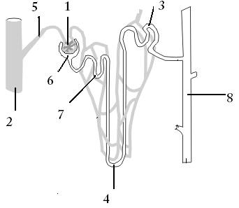

1._____________________________________ 2._____________________________________

3._____________________________________ 4._____________________________________

5._____________________________________ 6._____________________________________

7._____________________________________ 8._____________________________________

b. What is the function of structure 6? (2)

________________________________________________________________________________________

c. How is the composition of fluid in structure 8 different to the composition of the fluid inside structure 5? (2)

________________________________________________________________________________________

________________________________________________________________________________________

________________________________________________________________________________________

________________________________________________________________________________________

d. Which structure/structures does ADH affect the permeability of? (2)

________________________________________________________________________________________

________________________________________________________________________________________

**Question 2.**

Alex decided to go for a run around Lake Monger. She forgot to take her water bottle with her and began feeling a bit light headed and had a bit of a headache.

Complete the feedback loop to explain how Alex’s body is dealing with dehydration. (6)

**Effector**

**Response**

**Stimulus**

**Receptor**

**Feedback**

**Modulator**

**Question 3.**

Explain why the consumption of alcohol and caffeine increases the amount of urine that is produced. (2)

__________________________________________________________________________________________

__________________________________________________________________________________________

__________________________________________________________________________________________

__________________________________________________________________________________________

__________________________________________________________________________________________

__________________________________________________________________________________________

__________________________________________________________________________________________

__________________________________________________________________________________________

__________________________________________________________________________________________

**Question 4.**

Why can some substances pass through the membrane of the glomerulus, but others can not? Give examples. (2)

__________________________________________________________________________________________

__________________________________________________________________________________________

__________________________________________________________________________________________

__________________________________________________________________________________________

__________________________________________________________________________________________

__________________________________________________________________________________________

__________________________________________________________________________________________

**Question 5.**

Explain the difference between filtration, selective reabsorption and tubular secretion. You can use specific details and diagrams to help explain. (6)

__________________________________________________________________________________________

__________________________________________________________________________________________

__________________________________________________________________________________________

__________________________________________________________________________________________

__________________________________________________________________________________________

__________________________________________________________________________________________

__________________________________________________________________________________________

__________________________________________________________________________________________

__________________________________________________________________________________________

__________________________________________________________________________________________

__________________________________________________________________________________________

__________________________________________________________________________________________

__________________________________________________________________________________________

__________________________________________________________________________________________

__________________________________________________________________________________________

__________________________________________________________________________________________

__________________________________________________________________________________________

__________________________________________________________________________________________

__________________________________________________________________________________________